# Water indices

## Purpose

This module offers a set of functions to calculate water indices, both separate and in batch. At this moment 4 indices are supported:

* NDWI (normalized difference water index)
* LSWI 1 and LSWI 2 (Land Surface Water Index)
* TCWI (Tasseled cap wetness index)

## Installation

Install the .sav files in the save_add folder (see also [ENVI .sav files: Installation and configuration](http://www.itc.nl/personal/nieuwenh/installations.html).

nrsmenu.pro Define NRS menu item in ENVI

nrs_Utils.sav Library with utility routines

nrs_water_index.sav The actual software

## Usage (gui)

|  |  |
| --- | --- |
| nrs_water_index_GUI | Start the user interface of the water index (single) |
| nrs_water_index_batch_GUI | Start the user interface of the water index (batch) |

Alternatively the commands can be started from the ENVI menu: ‘NRS | Water indices:

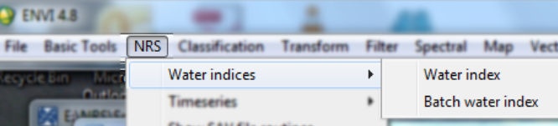

### Calculate Water Index (single)

Menu option is ‘NRS | Water indices | Water index, the command line is ‘nrs_water_index_gui’. This function calculates a single water index for MODIS BRDF products (MCD34A4). The four supported indices are NDWI, LSWI 1, LSWI 2 and TCWI.

Below is the user interface:

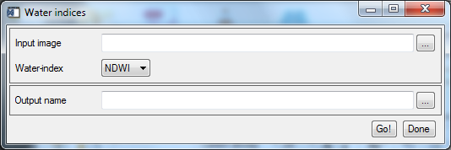

Explanation of all the fields:

|  |  |
| --- | --- |
| Input image | Select an input image. The software only test for the number of bands (which must be 7 for MODIS BRDF products) |
| Water index | Select the water index to calculate |
| Output name | The output name for the water index image. The software will propose a name based on the input and the water index |

The used formulas for the supported indices are:

$$NDWI=\frac{b_{4}-b_{2}}{b_{4}+b_{2}}$$

$${LSWI}_{1}=\frac{b_{2}-b_{5}}{b_{2}+b_{5}}$$

$${LSWI}_{2}=\frac{b_{2}-b_{6}}{b_{2}+b_{6}}$$

$$TCWI=0.10839b_{1}+0.0912b_{2}+0.5056b_{3}+0.404b_{4}-0.241b_{5}-0.4658b_{6}-0.5306b_{7}$$

### Calculate Water Index (batch)

Menu option is ‘NRS | Water indices | Batch water index, the command line is ‘nrs_water_index_gui’. This function accepts a series of input images and processes each input image separate with the water index function (see above).

The software either accepts a file list in a text file or a folder name where the files to process are located. In case of the text file: each line contains the name of a single MODIS BRDF product with a fully specified path. If the folder option is chosen, make sure that only MODIS BRDF images are located here; any other files will cause problems.

The user interface is shown below:

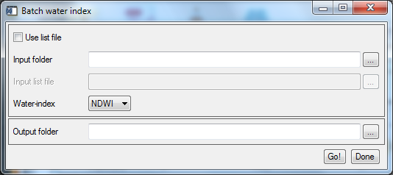

Explanation of all the fields:

|  |  |
| --- | --- |
| Use list file | Toggle between the list-file or folder option |
| Input folder | Select the folder where all images are located |
| Input list file | Select a text file with one image on each line (for example see below) |
| Water index | Select the water index to calculate |
| Output folder | The folder where all outputs will be stored; this folder needs to exist before running! |

### Example list file

E:\NRS\Lin Lin Li\data_folder\batch_in\file1.dat

E:\NRS\Lin Lin Li\data_folder\batch_in\file2.dat

E:\NRS\Lin Lin Li\data_folder\batch_in\file3.img

E:\NRS\Lin Lin Li\data_folder\batch_in\file4.img

Note: ENVI files are accompanied by .HDR files; these header files should **not** be in the list file!